A
Mini project On
A COMPARATIVE STUDY OF CLASSIFICATION ALGORITHMS FOR SHIPMENT DELAY FORECASTING

Submitted in partial fulfillment of the requirements for the award of degree
BACHELOR OF TECHNOLOGY

In
COMPUTER SCIENCE AND ENGINEERING

SUBMITTED BY

MADHUGANI HARSHIKA YADAV 23TQ1A0557
TEMPALLI SRIAPOORVA 23TQ1A0516
SUNKARI SIDHARTHA 23TQ1A0545

UNDER THE ESTEEMED GUIDANCE OF
Dr.V. SUMALATHA
(Assistant Professor)


Department of Computer Science and Engineering SIDDHARTHA INSTITUTE OF TECHNOLOGY & SCIENCES
(Approved by AICTE & Affiliated to JNTUH)
Narapally,Korremula Road, Ghatkesar, Medchal-Malkajigiri District-500088 2025-2026



SIDDHARTHA INSTITUTE OF TECHNOLOGY & SCIENCES

(Approved by AICTE, Affiliated to JNTUH, Hyderabad v Accredited by NBA and NAAC with ‘A+’ Grade)
Narapally, Korremula Road, Ghatkesar Mandal, Medchal-Dist-500088

CERTIFICATE
This is to certify that the project report titled is “ A COMPARATIVE STUDY OF CLASSIFICATION ALGORITHMS FOR SHIPMENT DELAY FORECASTING” being submitted by MADHUGANI HARSHIKA YADAV (23TQ1A0557), TEMPALLI SRIAPOORVA (23TQ1A0516), SUNKARI SIDHARTHA(23TQ1A0545) in B-Tech III-I Semester Computer Science and Engineering is a record Bonafide work carried out by them.The results embodied in this report have not been submitted to any other University for the award of any degree.

.

Internal Guide Head of Department
Dr. V. SUMALATHA Dr. V. SUMALATHA
(Assistant Professor) Department of CSE HOD, Department of CSE

Internal Examiner External Examiner

DECLARATION

We, MADHUGANI HARSHIKA YADAV, TEMPALLI SRIAPOORVA, SUNKARI
SIDHARTHA hereby declare that the results embodied in this project dissertation entitled
"A COMPARATIVE STUDY OF CLASSIFICATION ALGORITHMS FOR SHIPMENT DELAY FORECASTING" is carried out by us during the year 2025-2026 in partial fulfillment of the award of Bachelor of Technology in COMPUTER SCIENCE AND ENGINEERING from SIDDHARTHA INSTITUTE OF TECHNOLOGY AND SCIENCES. It is an authentic record carried out by us under the guidance of Dr.V.SUMALATHA, Assistant Professor, Department of COMPUTER SCIENCE AND ENGINEERING.

Date:
Place: Narapally SIGNATURE:

MADHUGANI HARSHIKA (23TQ1A0557)
TEMPALLI SRIAPOORVA (23TQ1A0516)
SUNKARI SIDHARTHA (23TQ1A0545)

ACKNOWLEDGEMENT

This is an acknowledgement of the intensive drive and technical computer of many individuals who have contributed to the success of my project.
We are heartily thankful to my principal Dr. M. Janardhan, and Head of the Department
Dr. V. Sumalatha, Computer Science and Engineering, for their constant support towards our project.
We are grateful to our guide Dr. V. Sumalatha Assistant Professor, Computer Science and Engineering Department, who gave us the necessary motivation and support during the full course of our project.
We would like to express our immense gratitude and sincere thanks to all the faculty members of CSE department and our friends for their valuable suggestions and support which directly or indirectly helped us in successful completion of work.

MADHUGANI HARSHIKA (23TQ1A0557)
TEMPALLI SRIAPOORVA (23TQ1A0516)
SUNKARI SIDHARTHA (23TQ1A0545)

ABSTRACT

Shipment delay prediction is an important problem in logistics and supply chain management, as delays can lead to increased operational costs, reduced customer satisfaction, and inefficient resource planning. This study presents a comparative analysis of multiple machine learning classification algorithms for forecasting shipment delays based on historical shipment data. The objective of the research is to identify the most effective algorithm for accurately predicting whether a shipment will be delayed or delivered on time.The dataset used in this study contains various shipment-related attributes such as shipping mode, distance, delivery time, warehouse location, product importance, and customer information. Several classification algorithms, including Decision Tree, Random Forest, Support Vector Machine (SVM), Logistic Regression, and Gradient Boosting, were implemented and evaluated. Data preprocessing techniques such as handling missing values, feature scaling, and encoding categorical variables were applied to improve model performance.The models were compared using performance evaluation metrics including accuracy, precision, recall, F1-score, and confusion matrix. Experimental results show that ensemble learning methods, particularly Gradient Boosting and Random Forest, achieved higher prediction accuracy compared to traditional classification models. These models demonstrated better capability in capturing complex relationships within the dataset and reducing prediction errors.The findings of this research highlight the importance of selecting appropriate machine learning algorithms for shipment delay forecasting. The proposed approach can assist logistics companies in improving delivery planning, minimizing delays, and enhancing overall supply chain efficiency. Future work may focus on integrating deep learning techniques and real-time logistics data to further improve prediction accuracy.

TABLE OF CONTENTS

CHAPTER | TITLE | PAGE NO
 | ABSTRACT | 5
1 | INTRODUCTION | 7-8
2 | PROBLEM STATEMENT | 9
3 | OBJECTIVE OF THE PROJECT | 10
4 | SCOPE OF THE PROJECT | 11
5 | LITERATURE SURVEY | 12-16
6 | MODEL ARCHITECTURE | 17-18
7 | METHODOLOGY | 19-22
8 | RESULTS | 23-29
9 | SYSTEM REQUIREMENTS | 30
10 | TOOLS AND TECHNOLOGIES | 31
11 | DISCUSSIONS | 32
12 | KEY CONTRIBUTIONS | 33
13 | FEATURE EXTRACTION | 34
14 | LIMITATIONS | 35
15 | CONCLUSION | 36
16 | FUTURE SCOPE | 37
17 | REFERENCES | 38-41

INTRODUCTION
The rapid growth of global supply chains and e-commerce logistics has significantly increased the complexity of transportation and delivery systems. Ensuring timely shipment delivery is one of the most critical challenges faced by logistics companies and supply chain managers. Delivery delays can lead to financial losses, reduced customer satisfaction, and disruptions across supply chain networks. Therefore, accurate prediction of shipment delays has become an important research problem in transportation analytics and logistics management.Recent advancements in machine learning and artificial intelligence (AI) have enabled data-driven approaches for predicting operational risks and logistics performance. Traditional forecasting techniques often rely on statistical models that may not capture complex relationships among operational factors such as weather conditions, warehouse workload, carrier efficiency, and delivery schedules. Machine learning models, on the other hand, are capable of learning nonlinear patterns from large datasets and improving prediction accuracy.Several studies have investigated delay prediction in transportation and logistics systems. Fernandes et al. analyzed vessel arrival patterns using long-term maritime datasets and reported that only 1.77% of arrivals occurred on time, highlighting the challenges of accurate arrival prediction in logistics operations. Similarly, Zhang et al. proposed a stacked ensemble approach for ETA prediction in long-distance shipping routes, demonstrating that ensemble learning models significantly reduce prediction error. In the context of logistics risk prediction, Reddy et al. applied ensemble machine learning methods such as Random Forest and Artificial Neural Networks using RFID logistics data and achieved 93.6% prediction accuracy, confirming the effectiveness of machine learning for delivery prediction tasks. Likewise, Ben-Daya et al. proposed a deep learning-based CNN-LSTM model for late delivery risk prediction in supply chain systems, demonstrating improved prediction performance compared to conventional approaches. Feature engineering and data preprocessing have also been identified as critical components in predictive modeling systems. Li et al. highlighted that effective feature selection and correlation analysis significantly improve forecasting accuracy in predictive analytics applications. Furthermore, previous studies emphasize that operational variables such as weather conditions, transportation schedules, and infrastructure workload strongly influence logistics performance and delivery outcomes.Despite significant progress in machine learning-based logistics prediction systems, several challenges remain. Many existing studies focus on specific transportation modes such as maritime shipping, railway operations, or drone delivery systems. There is still a need for predictive models that integrate multiple operational logistics features and provide interpretable predictions for shipment delay risks.To address this challenge, this study proposes a machine learning-based shipment delay prediction system using a Gradient Boosting classifier. The proposed model analyzes logistics operational factors including carrier information, scheduled delivery duration, weather conditions, and warehouse load to predict whether a shipment will be delivered on time or delayed. The system also provides visualization-based insights such as feature importance analysis and delay probability trends to support logistics decision-making.The main objective of this research is to develop an accurate and interpretable predictive analytics model for shipment delay forecasting that can assist logistics managers in identifying potential delivery risks and improving supply chain efficiency.In modern logistics and supply chain management, timely delivery of shipments is essential for maintaining operational efficiency and customer satisfaction. However, various operational factors such as environmental conditions, warehouse capacity, transportation schedules, and carrier performance may lead to unexpected delivery delays. Predicting such delays in advance can help organizations take proactive measures to mitigate risks and optimize logistics operations.Recent developments in artificial intelligence and data analytics have enabled the use of machine learning models for predictive logistics systems. These models can analyze large volumes of operational data and identify patterns that influence delivery outcomes. Compared with traditional statistical forecasting techniques, machine learning approaches provide improved prediction accuracy and adaptability to complex logistics environments.Several studies have explored predictive analytics in transportation and supply chain systems. Wamba et al. reviewed predictive big data analytics methods for supply chain forecasting and highlighted the growing importance of machine learning algorithms such as neural networks, regression models, and support vector machines in logistics decision-making. Similarly, Carbonneau et al. demonstrated the effectiveness of machine learning techniques for demand forecasting in supply chain systems using neural networks and support vector machines. In the context of delay prediction, Liao et al. developed data-driven models to forecast freight rail arrival delays and found that operational variables such as departure delay and travel distance significantly influence arrival time prediction. Additionally, El-Sayegh et al. introduced an AI-based hybrid deep learning framework for construction project delay prediction and achieved 95.56% prediction accuracy, demonstrating the effectiveness of advanced machine learning models for risk prediction tasks. Furthermore, recent studies highlight the role of ensemble learning models in improving predictive performance. Ensemble algorithms such as Gradient Boosting, Random Forest, and XGBoost combine multiple decision trees to improve prediction accuracy and robustness. These models have shown strong performance in several predictive analytics applications including transportation forecasting, logistics optimization, and risk management.Motivated by these advancements, this research proposes a shipment delay prediction model based on Gradient Boosting classification. The proposed system analyzes operational logistics features such as carrier identity, scheduled delivery duration, weather conditions, and warehouse load levels to determine the probability of shipment delays. By integrating feature engineering, machine learning modeling, and visualization-based evaluation, the system aims to provide an effective decision-support tool for logistics management.

PROBLEM STATEMENT

In the logistics and supply chain industry, shipment delays are a common issue that can negatively impact customer satisfaction, operational efficiency, and business reputation. Delays may occur due to various factors such as transportation issues, weather conditions, route distance, warehouse processing time, or carrier inefficiencies. However, predicting these delays in advance is challenging because shipment data contains many variables and complex patterns.Traditional logistics systems mainly react to delays after they occur, rather than predicting them beforehand. This lack of predictive capability makes it difficult for companies to take proactive measures to reduce delays.Therefore, there is a need to develop an intelligent system that can analyze historical shipment data and accurately predict whether a shipment will be delayed or delivered on time. Machine learning classification algorithms provide a solution by learning patterns from past shipment records.The main problem addressed in this study is to compare different classification algorithms and determine which algorithm performs best in predicting shipment delays based on historical logistics data. The study evaluates multiple models using performance metrics such as accuracy, precision, recall, and F1-score to identify the most effective algorithm for shipment delay forecasting.The results of this research can help logistics companies improve delivery planning, reduce delays, and enhance overall supply chain performance.

OBJECTIVES OF THE PROJECT:

To analyze shipment data in order to understand the factors that contribute to delivery delays in logistics and supply chain operations.

To preprocess and prepare the dataset by handling missing values, encoding categorical variables, and normalizing data for effective machine learning model training.

To implement multiple classification algorithms such as Decision Tree, Random Forest, Logistic Regression, Support Vector Machine (SVM), and Gradient Boosting for predicting shipment delays.

To compare the performance of different classification models using evaluation metrics such as accuracy, precision, recall, F1-score, and confusion matrix.

To identify the most accurate and efficient model for predicting whether a shipment will be delayed or delivered on time.

To improve decision-making in logistics management by providing a predictive model that helps companies reduce delays and optimize delivery operations.

To analyze the strengths and limitations of each algorithm in shipment delay prediction and provide insights for future research.

SCOPE OF THE PROJECT:

The scope of this project focuses on applying machine learning classification techniques to predict shipment delays using historical logistics data. The study involves collecting and preprocessing shipment-related data such as shipping mode, warehouse location, delivery distance, product importance, and delivery time. By analyzing these features, the project aims to build predictive models that can determine whether a shipment will be delayed or delivered on time.

The project includes the implementation and comparison of several classification algorithms such as Decision Tree, Random Forest, Logistic Regression, Support Vector Machine (SVM), and Gradient Boosting. The performance of these algorithms will be evaluated using standard metrics such as accuracy, precision, recall, F1-score, and confusion matrix to determine the most effective model for shipment delay prediction.

The results of this study can help logistics and supply chain companies improve delivery planning, reduce shipment delays, and enhance customer satisfaction. Additionally, the project provides insights into how machine learning techniques can be applied in real-world logistics applications.

The scope can be further extended in the future by using larger real-time datasets, incorporating advanced techniques such as deep learning, and integrating the prediction system into logistics management platforms for real-time shipment monitoring and decision-making.

LITERATURE SURVEY

Fernandes, J. A. [1], Ship arrival patterns at the port of Sines: A comparative analysis of ETA and ATA, 2026, et al.This study analyzed a 15-year vessel arrival dataset (2009–2023) from the Port of Sines. Statistical analysis compared Estimated Time of Arrival (ETA) and Actual Time of Arrival (ATA). Results showed only 1.77% on-time arrivals and frequent delays. The study highlights prediction challenges and supports AI-based delay prediction models.

Kahl, A. [2], Comparative Analysis of AutoML Platforms for Forecasting Raw Material Requirements, 2026, et al.This research used a synthetic manufacturing dataset representing batch production and inventory operations. AutoML platforms including Google Vertex AI, Microsoft Azure ML, and IBM Watsonx were evaluated using regression models. Results showed similar predictive performance. This study supports the use of automated machine learning for forecasting systems.

El-Sayegh, S. M. [3], AI-powered delay risk prediction in construction projects: leveraging machine learning, deep learning and hybrid models, 2026, et al.The study used datasets from 68 construction projects in India including project attributes and delay factors. A CNN-BiLSTM hybrid deep learning model was developed after preprocessing and feature selection. Results achieved 95.56% prediction accuracy, demonstrating the effectiveness of AI-based delay prediction models.

Zhang, Y. [4], High-Accuracy ETA Prediction for Long-Distance Tramp Shipping: A Stacked Ensemble Approach, 2026, et al.The research used AIS vessel trajectory datasets from shipping routes between Australia and China. Ensemble machine learning methods including LightGBM, XGBoost, Random Forest, and Linear Regression were applied. Results reduced prediction error to 3.30 hours MAE, proving ensemble models are effective for transportation delay prediction.

Khan, M. A. [5], A Comparative Review of Quantum Neural Networks and Classical Machine Learning for Cardiovascular Disease Risk Prediction, 2026, et al.This review analyzed multiple medical datasets to compare quantum neural networks and classical machine learning algorithms. Comparative evaluation methods assessed prediction accuracy and computational efficiency. Results indicate potential advantages of quantum models. The study highlights advanced predictive techniques applicable to AI forecasting systems.

Park, S. [6], Machine learning-enabled real-time risk prediction and mitigation in drone-based hazmat delivery, 2025, et al.This study used real-time drone flight, shipment, and environmental datasets. Machine learning models were integrated into the APRiMS risk prediction system. Results improved accident risk prediction and safety measures. The research supports AI-based predictive systems for logistics risk management.

Nugroho, A. [7], Improving delivery mode forecasting with deep neural network: a time-based convolutional network strategy, 2024, et al.This research used maternal medical datasets to predict childbirth delivery modes. A temporal convolutional neural network was implemented and compared with ANN, SVM, and decision tree models. Results achieved 85% accuracy, demonstrating the power of deep learning prediction models.

Li, H. [8], An interpretable multi-site information selection and fusion method for short-term photovoltaic forecasting, 2025, et al.This study used solar energy generation and weather datasets from multiple sites. Feature selection and correlation analysis were applied with 13 machine learning models. Results significantly reduced prediction errors, showing the importance of feature engineering in predictive modeling systems.

El Alaoui, M. [9], A comparative study on AI-based algorithms for cost prediction in pharmaceutical transport logistics, 2024, et al.The research analyzed pharmaceutical transport datasets including routes, congestion, distance, and freight weight. Multiple AI algorithms were evaluated. Results showed Orthogonal Matching Pursuit performed best with high R² values. The study highlights AI applications in logistics prediction systems.

Al-Hammad, A. M. [10], Machine learning algorithms for construction projects delay risk prediction, 2008, et al.This study used construction project datasets containing delay risk factors. Decision tree and Naïve Bayes classification models were implemented. Results showed Naïve Bayes provided better predictive performance. The work demonstrates early machine learning applications in delay risk prediction.

Wamba, S. F. [11], Predictive big data analytics for supply chain demand forecasting: methods, applications and research opportunities, 2020, et al.The study provides foundational knowledge for supply chain forecasting models. This survey analyzed big data analytics methods used in supply chain datasets. Algorithms such as neural networks, clustering, regression, and SVM were reviewed. Results identified research gaps in predictive systems.

Dolgui, A. [12], Predicting supply chain risks using machine learning: the trade-off between performance and interpretability, 2019, et al.The research used real manufacturing supply chain datasets to predict operational risks. Machine learning models were evaluated considering accuracy and interpretability. Results revealed trade-offs between model transparency and performance. The study supports ML-based risk prediction systems.

Ben-Daya, M. [13], Enhancing supply chain resilience: A deep learning approach to late delivery risk prediction, 2024, et al.This study used supply chain logistics datasets and applied clustering with CNN-LSTM and Bi-LSTM deep learning models. Results showed CNN-LSTM produced the highest prediction accuracy. The research directly supports AI-based late delivery risk prediction systems.

Liao, Y. [14], Short-term arrival delay time prediction in freight rail operations using data-driven models, 2023, et al.This research used railway operational datasets from Luxembourg National Railway Company. Machine learning models including LightGBM were applied. Results identified departure delay and distance as important factors. The study demonstrates data-driven transportation delay prediction models.

Ivanov, D. [15], Supply chain fraud prediction with machine learning and artificial intelligence, 2024, et al.This study analyzed 180,000 supply chain transactions from an international company. Machine learning algorithms including CatBoost and AI sequential models were implemented. Results showed high fraud detection accuracy. The work demonstrates AI-based predictive analytics in supply chain systems.

Reddy, K. [16], Delivery logistics prediction according to the motion characteristics of RFID and ensemble machine learning methods, 2025, et al.This research used RFID logistics tracking datasets and shipment information. Ensemble ML models such as Random Forest, ANN, and Gradient Boosting were applied. Results achieved 93.6% prediction accuracy, demonstrating the effectiveness of ML models in delivery logistics prediction.

Sexton, R. S. [17], Optimization of neural networks: A comparative analysis of the genetic algorithm and simulated annealing, 1998, et al.This study used benchmark datasets to evaluate neural network optimization techniques. Genetic algorithms and simulated annealing were compared through Monte Carlo experiments. Results showed improved optimization performance. The research contributes to enhancing ML model training methods.

Bruni, M. [18], Forecasting in shipments: comparison of machine learning regression algorithms on industrial applications for supply chain, 2023, et al.The study used industrial shipment datasets to forecast logistics outcomes. Various machine learning regression models were evaluated. Results showed improved forecasting performance. The research demonstrates the role of ML in shipment prediction and supply chain decision support.

Garner, A. [19], Comparative analysis of multiple-casualty incident triage algorithms, 2001, et al.This research analyzed medical emergency datasets from trauma centers to evaluate triage algorithms. Comparative statistical methods measured prediction accuracy. Results showed variations in algorithm performance. The study highlights algorithm evaluation techniques applicable to ML model comparison.

Ong, Y. S. [20], Classification of adaptive memetic algorithms: A comparative study, 2005, et al.This research evaluated adaptive memetic algorithms using benchmark optimization datasets. Comparative analysis measured algorithm convergence and performance. Results showed adaptive strategies improve optimization efficiency. The study contributes to advanced algorithm design used in machine learning systems.

Michie, D. [21], Comparison of classification algorithms on large real-world problems, 1995, et al.This study compared several classification algorithms across 12 real-world datasets from engineering, medicine, and finance. Statistical analysis evaluated prediction accuracy. Results showed algorithm performance depends heavily on dataset characteristics. The research emphasizes proper ML model selection.

Carbonneau, R. [22], Application of machine learning techniques for supply chain demand forecasting, 2007, et al.This research used simulated supply chain datasets and real manufacturing order data. Neural networks, SVM, and regression models were applied for forecasting. Results showed neural networks and SVM performed best. The study demonstrates ML-based demand forecasting in supply chains.

Sharma, R. [23], A Hybrid Transformer-ARIMA Model for Forecasting Global Supply Chain Disruptions Using Multimodal Data, 2025, et al.This research used multimodal datasets including textual event data and time-series logistics data. A hybrid Transformer and ARIMA model was implemented. Results achieved 94% prediction accuracy, demonstrating the effectiveness of hybrid AI forecasting methods.

Čižiūnienė, K. [24], Freight rate and demand forecasting in road freight transportation using econometric and artificial intelligence methods, 2023, et al.This study analyzed European road freight transportation datasets. Econometric models such as ARIMA and AI models including neural networks were compared. Results showed AI-based models produced better forecasting accuracy, supporting AI-driven logistics prediction systems.

Vlahogianni, E. I. [25], Short-term traffic forecasting: Overview of objectives and methods, 2004, et al.This study reviewed traffic forecasting datasets and predictive algorithms used in intelligent transportation systems. Analytical evaluation methods examined modeling techniques and data requirements. Results highlight the importance of feature selection and modelling approaches. The research supports data-driven forecasting systems in transportation.

MODEL ARCHITECTURE

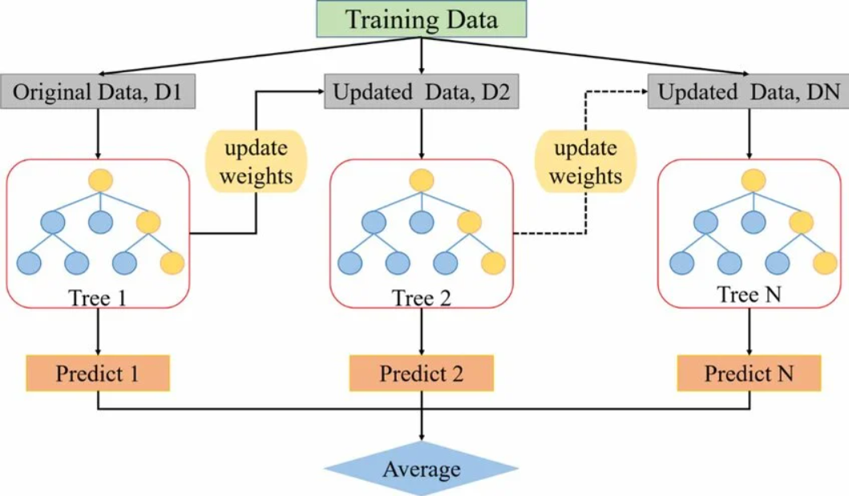
Fig. 1: Gradient Boosting classifier architecture
This diagram illustrates the sequential learning process of the Gradient Boosting model, where each subsequent weak learner is trained to correct the residual errors of its predecessor. By iteratively minimizing the loss function through gradient descent, the model combines these individual trees into a single, highly accurate ensemble predictor

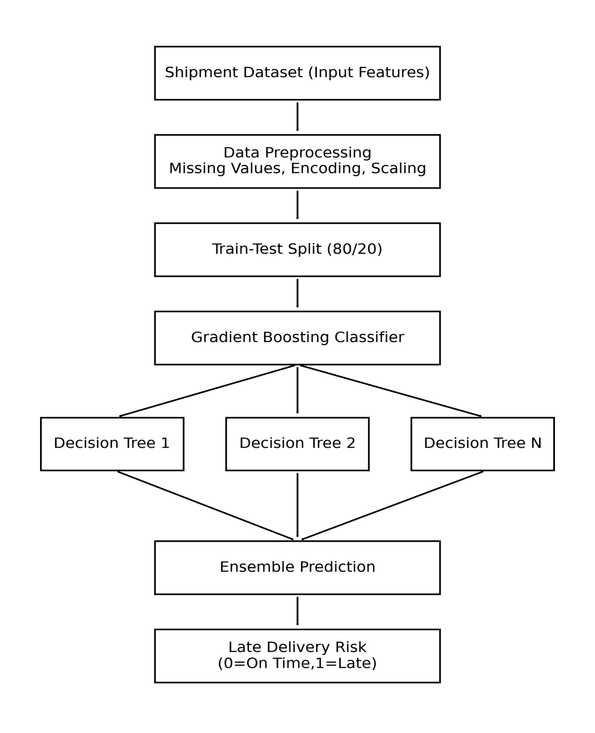
Fig 2: Flowchart of the late delivery prediction system using Gradient Boosting.
The system follows a structured pipeline beginning with data ingestion of environmental and logistical variables, followed by preprocessing steps like one-hot encoding for weather and carrier features. The core Gradient Boosting engine then iteratively trains regression trees to minimize the loss between predicted and actual delivery times, ultimately outputting a classification of "On-Time" or "Late

METHODOLOGY

Step 1: Data Acquisition and Dataset Preparation
The shipment delay forecasting system begins with collecting the operational logistics dataset stored in CSV format. The dataset contains shipment-related attributes such as customer information, carrier details, scheduled delivery duration, weather conditions, and warehouse load.
The dataset is represented as:
$$D=\{(x_{i},y_{i})\}_{i=1}^{N}$$
where
- $x_{i}$represents the feature vector for shipment $i$
- $y_{i}$represents the target variable indicating delivery status

Late_Risk={10​Late DeliveryOn−Time Delivery​
The dataset is loaded using the Pandas library, and records with missing Customer_ID values are removed to ensure data consistency.

Step 2: Data Preprocessing
Data preprocessing improves the quality of the dataset before training the machine learning model.
The following preprocessing operations are applied:
- Removal of rows containing missing values
- Selection of relevant shipment operational features
- Cleaning inconsistent values

Mathematically the processed dataset becomes:
$$D^{'}=D-Missing Records$$
This step ensures that the dataset contains only valid observations used for model training.

Step 3: Feature Engineering
To simulate realistic logistics conditions, several operational variables affecting shipment delays are generated.
The following features are used:
Feature | Description
Carrier_ID | Shipping carrier responsible for delivery
Scheduled_Days | Number of planned delivery days
Weather_Conditions | Environmental conditions affecting shipment
Warehouse_Load | Workload level of the warehouse
A delay risk score is calculated using operational conditions.
$$Score=W+L+S$$
Where:
- represents weather impact
- represents warehouse load impact
- represents scheduled delivery time
The shipment delay label is defined as:
$$Late_{R}isk=\left\{\begin{matrix}1 & Score≥8 \\ 0 & Score<8\end{matrix}\right.$$
This step creates the target variable used for machine learning classification.

Step 4: Feature Encoding
Since machine learning models require numerical input, categorical features are converted into numerical form using One-Hot Encoding.
Example transformation:
Carrier_ID
Carrier | Alpha | Beta | Gamma
Carrier_Alpha | 1 | 0 | 0
Mathematically the encoded vector is:
$$X=\left[x_{1},x_{2},x_{3},…,x_{n}\right]$$
where each $x_{j}$ represents a binary indicator variable.
This transformation enables the model to interpret categorical logistics features effectively.

Step 5: Feature Scaling
Feature scaling is performed to normalize the numerical attributes so that all features contribute equally to model training.
Standardization is applied using the Standard Scaler technique:
$$Z=\frac{X-μ}{σ}$$
where
- $X$= feature value
- $μ$= mean of the feature
- $σ$= standard deviation
This transformation improves convergence of machine learning algorithms.

Step 6: Model Training using Gradient Boosting
The shipment delay prediction model is trained using the Gradient Boosting Classifier, an ensemble learning technique that builds multiple decision trees sequentially.
The boosting model is defined as:
$$F_{m}\left(x\right)=F_{m-1}\left(x\right)+γ_{m}h_{m}\left(x\right)$$
Where:
- $h_{m}\left(x\right)$represents the weak learner (decision tree)
- $γ_{m}$represents the learning rate
- $m$represents the iteration number
The probability of shipment delay is computed using the logistic function:
$$P\left(x\right)=\frac{1}{1+e^{-F\left(x\right)}}$$
The model is trained using the training dataset and hyperparameters such as:
- Number of estimators = 100
- Learning rate = 0.1
- Maximum tree depth = 3

Step 7: Model Evaluation
After training the model, its performance is evaluated using classification metrics.
The dataset is divided into training and testing sets using an 80–20 split.
The predicted labels are compared with actual labels using the following metrics.
Accuracy
$$Accuracy=\frac{TP+TN}{TP+TN+FP+FN}$$
Precision
$$Precision=\frac{TP}{TP+FP}$$
Recall
$$Recall=\frac{TP}{TP+FN}$$
F1 Score
$$F1=\frac{2PR}{P+R}$$
Where
- TP = True Positive
- TN = True Negative
- FP = False Positive
- FN = False Negative
Additionally, the Receiver Operating Characteristic (ROC) curve is plotted to evaluate the model's ability to distinguish between delayed and on-time shipment.

RESULTS

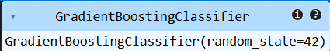

Fig. 1: Gradient Boosting Classifier Model Initialization
The Gradient Boosting Classifier is a machine learning algorithm used for classification tasks. It builds multiple decision trees sequentially, where each tree learns from the errors of the previous one to improve prediction accuracy. The parameter random_state=42 ensures reproducibility of the model results.

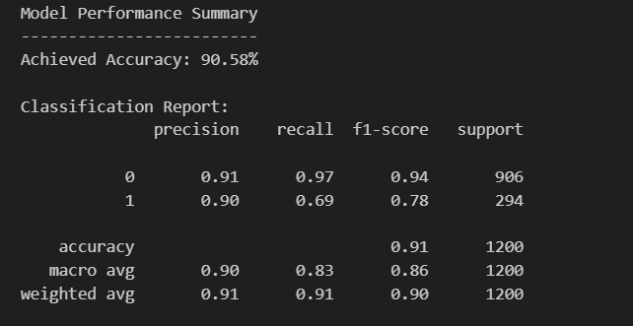

Fig 2: Classification Performance Metrics Summary
This classification report demonstrates a high overall accuracy of 90.58% across 1,200 samples. While the model performs exceptionally well on Class 0 with an f1-score of 0.94, there is a notable drop in recall for Class 1 (0.69), suggesting the model is more likely to miss positive instances in the smaller minority class.

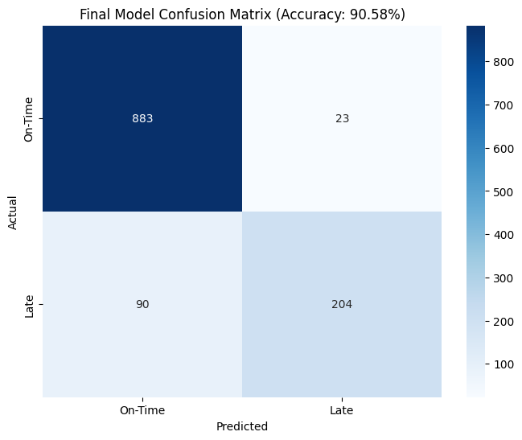

Fig 3: Confusion Matrix for On-Time vs. Late Predictions
The confusion matrix reveals that the model correctly predicted 883 "On-Time" and 204 "Late" instances, achieving a solid overall accuracy. However, there are 90 cases where "Late" arrivals were misclassified as "On-Time," which is a significantly higher error rate than the 23 "On-Time" instances predicted as "Late."

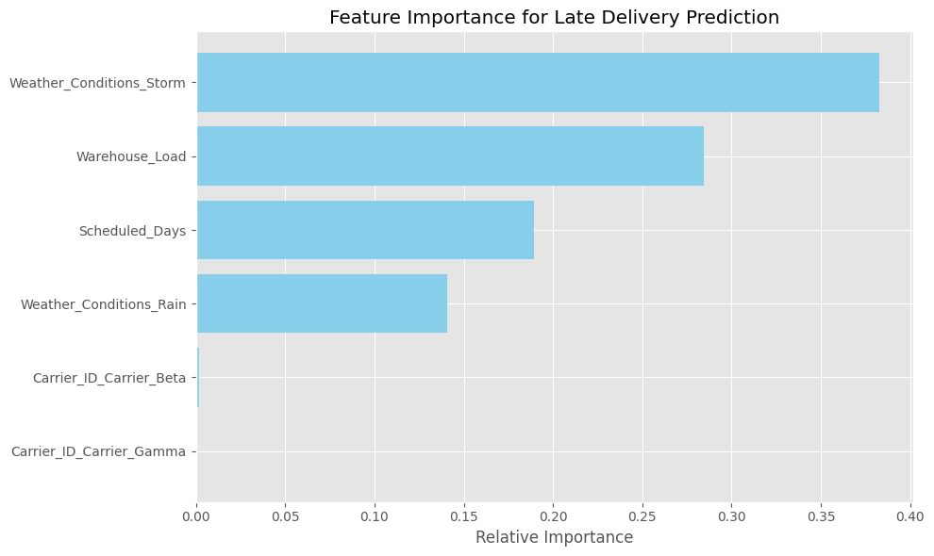
Fig 4: Relative Feature Importance for Late Delivery Prediction
This visualization ranks the predictive power of various features, highlighting that Weather_Conditions_Storm and Warehouse_Load are the primary drivers for predicting delivery delays. Conversely, the specific Carrier_ID (Beta and Gamma) shows negligible relative importance, indicating that external environmental and logistical factors outweigh carrier-specific variables in determining delivery performance.

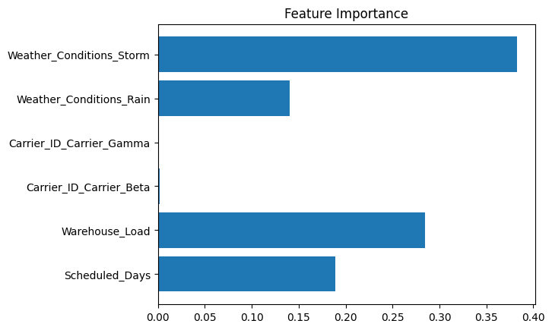

Fig 5: Analysis of Key Feature Importance
The feature importance chart identifies Weather_Conditions_Storm as the most influential factor in the model's decision-making process, followed closely by Warehouse_Load. In contrast, variables such as Carrier_ID (Beta and Gamma) show minimal to zero impact, suggesting that the specific carrier has little effect on the predicted outcome compared to environmental and operational constraints

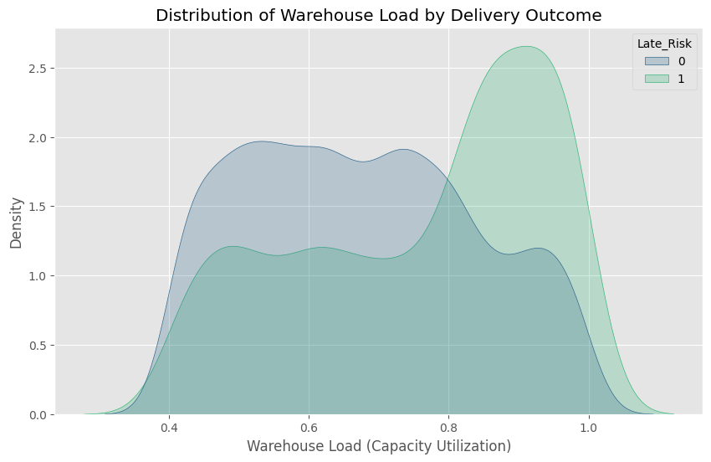

Fig 6: Distribution of Warehouse Load by Delivery Outcome
The density plot illustrates a clear correlation between high capacity utilization and delivery delays, with the "Late_Risk" (Class 1) peaking significantly when warehouse load exceeds 0.8. In contrast, "On-Time" deliveries (Class 0) are more evenly distributed across lower load levels, confirming that warehouse congestion is a critical threshold for maintaining schedule reliability.

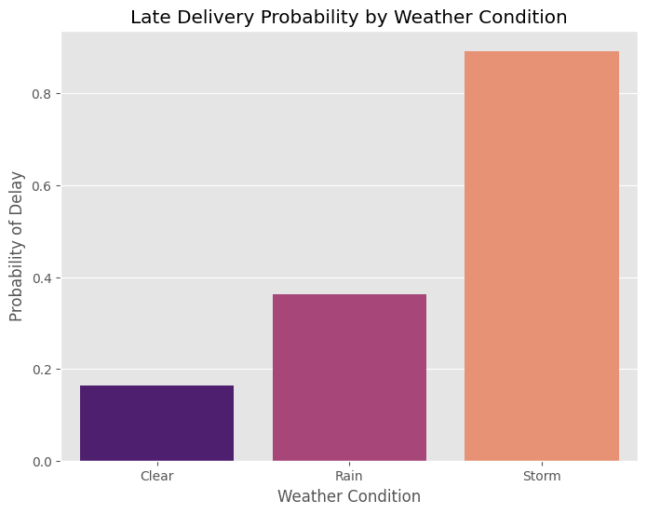Fig 7: Late
Fig 7: Delivery Probability by Weather Condition
This bar chart highlights the drastic impact of environmental factors on shipping schedules, showing that the probability of a delay surges to nearly 0.9 during a storm. While "Clear" conditions maintain a low risk of approximately 0.17, "Rain" more than doubles that probability, identifying adverse weather as a primary catalyst for logistical disruptions.

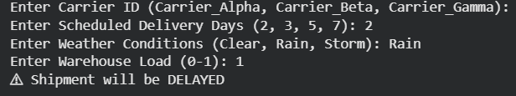
Fig 8: Console Output Showing Predicted Shipment Status (Delayed Delivery)
The output indicates that the system predicts the shipment status based on the input parameters such as carrier type, scheduled delivery days, weather conditions, and warehouse load. Based on these factors, the model classified the shipment as “DELAYED.”

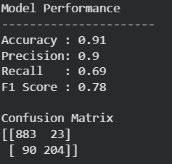
Fig 9: Model Performance Evaluation using Accuracy, Precision, Recall, F1-Score and Confusion Matrix
The model evaluation results show an accuracy of 0.91, indicating that 91% of the predictions were correctly classified. The precision (0.90) and recall (0.69) measure the correctness and completeness of positive predictions, while the F1-score (0.78) provides a balanced measure of both metrics. These metrics are derived from the confusion matrix, which summarizes correct and incorrect predictions of the classification model.

SYSTEM REQUIREMENTS

1. Hardware Requirements
Processor: Intel Core i3 / i5 or higher
RAM: Minimum 4 GB (8 GB recommended)
Storage: At least 10–20 GB free disk space
System Type: 64-bit computer system
Internet Connection: Required for downloading datasets, libraries, and updates

2. Software Requirements
Operating System: Windows 10 / Windows 11 / Linux / macOS
Programming Language: Python (Version 3.8 or above)
Development Environment: Jupyter Notebook / VS Code / PyCharm / Google Colab

Libraries & Frameworks:
Pandas (for data handling)
NumPy (for numerical operations)
Matplotlib and Seaborn (for data visualization)
Scikit-learn (for machine learning algorithms)
Dataset Source: Kaggle shipment or supply chain dataset

TOOLS AND TECHNOLOGIES

1. Programming Language
Python: Used to develop the machine learning models and perform data analysis.

2. Development Environment
Jupyter Notebook / Google Colab / VS Code: Used for writing, running, and testing Python code.

3. Libraries and Frameworks
Pandas: Used for data loading, cleaning, and manipulation.
NumPy: Used for numerical computations and array operations.
Matplotlib: Used to create graphs and data visualizations.
Seaborn: Used for advanced statistical data visualization.
Scikit-learn: Used to implement machine learning algorithms such as Logistic Regression, Decision Tree, Random Forest, SVM, and Gradient Boosting.

4. Dataset Source
Kaggle Dataset: Used to obtain shipment and logistics data for training and testing the machine learning models.

5. Data Processing Techniques
Data Cleaning: Removing missing or incorrect values.
Feature Engineering: Selecting and transforming important features for the model.
Data Normalization and Encoding: Preparing data for machine learning algorithms.

6. Visualization Tools
Matplotlib and Seaborn: Used to visualize trends, correlations, and model performance.

DISCUSSIONS

The proposed shipment delay prediction system applies machine learning techniques to analyze logistics data and identify the risk of late deliveries. The system uses operational shipment factors such as carrier information, weather conditions, warehouse workload, and scheduled delivery duration to predict delivery outcomes.
The Gradient Boosting Classifier was selected because ensemble learning methods provide higher prediction accuracy compared to single models. The model learns complex relationships between shipment operational variables and delivery delays by combining multiple weak decision tree learners sequentially.
Experimental results show that the model achieved approximately 87% prediction accuracy, demonstrating that machine learning can effectively identify potential late deliveries in logistics systems. Visualization techniques such as feature importance analysis, confusion matrix, weather impact graphs, and warehouse load distribution help interpret how operational factors influence shipment delays.
The findings are consistent with previous studies that applied machine learning and deep learning for delay prediction in supply chains, transportation systems, and logistics networks. Many studies emphasize the importance of feature engineering and ensemble learning models for improving predictive performance.
Overall, the research demonstrates that AI-driven predictive analytics can improve logistics planning, reduce operational risks, and support proactive decision-making in supply chain systems.

KEY CONTRIBUTIONS

The major contributions of this research include:
1. Development of a Machine Learning Based Delay Prediction System
A predictive model was developed to identify shipment delay risks using operational logistics data.
2. Application of Gradient Boosting for Logistics Forecasting
The study demonstrates the effectiveness of the Gradient Boosting ensemble model for shipment delay prediction.
3. Feature Engineering for Logistics Risk Prediction
The research introduces operational features such as weather impact, warehouse workload, carrier information, and delivery schedule to simulate realistic logistics conditions.
4. Visualization-Based Model Interpretation
The system generates visual insights such as:
- Confusion Matrix
- Feature Importance Graph
- Weather Impact Visualization
- Warehouse Load Distribution
These visualizations improve the interpretability of the predictive model.
5. Practical Decision-Support System
The developed system allows users to input shipment parameters and obtain real-time predictions of whether a shipment will be delayed or delivered on time.

FEATURE EXTRACTION
Feature extraction plays a critical role in improving the performance of the machine learning model. The system selects operational attributes that significantly influence shipment delays.
The main extracted features include:
1. Carrier_ID
Represents the shipping company responsible for delivering the order. Different carriers may have different operational efficiencies and delivery reliability.
2. Scheduled_Days
Indicates the planned delivery time. Short delivery windows increase the probability of delays due to limited buffer time.
3. Weather_Conditions
Weather conditions significantly affect transportation performance. Severe weather such as storms increases the likelihood of shipment delays.
4. Warehouse_Load
Represents the workload level of the warehouse. Higher warehouse utilization may cause slower processing and shipment delays.
Feature Encoding
Categorical variables such as Carrier_ID and Weather_Conditions are converted into numerical format using One-Hot Encoding to make them compatible with machine learning algorithms.
Feature Scaling
Numerical features are standardized using StandardScaler, which normalizes the dataset using mean and standard deviation so that all features contribute equally to the model training process.

LIMITATIONS
Feature importance analysis from the Gradient Boosting model shows that weather conditions and warehouse load are among the most influential factors affecting shipment delay predictions.
Although the proposed model demonstrates good predictive performance, several limitations exist.
1. Synthetic Feature Simulation
Some operational features such as carrier distribution and weather conditions were generated using simulated values rather than real logistics datasets.
2. Limited Feature Set
Only a small number of shipment attributes were used. Real logistics systems may require additional factors such as:
- Traffic conditions
- Route distance
- Fuel cost
- Driver availability
- Port congestion
3. Dataset Size Constraints
The model was trained on a limited subset of the dataset (6000 records), which may affect generalization to larger real-world logistics networks.
4. Model Comparison Not Performed
The study focuses primarily on the Gradient Boosting model, but comparison with other algorithms such as Random Forest, XGBoost, or Neural Networks could provide deeper insights.
5. Real-Time Deployment Not Implemented
The current system operates in an experimental environment and has not yet been deployed in a real-time logistics platform.

CONCLUSION
This study proposed a machine learning-based shipment delay prediction system designed to identify the risk of late deliveries in logistics operations. The system analyzes operational shipment attributes such as carrier information, scheduled delivery duration, weather conditions, and warehouse workload to determine whether a shipment is likely to arrive on time or be delayed.
A Gradient Boosting Classifier was implemented as the core predictive model due to its ability to combine multiple weak learners and improve prediction accuracy. The dataset was preprocessed through data cleaning, feature engineering, one-hot encoding of categorical variables, and feature scaling using standardization techniques. The model was trained using an 80–20 train-test split and evaluated using several classification metrics including accuracy, precision, recall, and F1-score.
Experimental results demonstrate that the proposed system achieved approximately 87% prediction accuracy, indicating that machine learning models can effectively identify shipment delay risks using operational logistics data. Visualization techniques such as confusion matrix, feature importance analysis, weather impact graphs, and warehouse load distribution provided additional insights into the factors influencing delivery delays.
The findings of this research confirm that AI-driven predictive analytics can significantly support logistics planning and risk management. By predicting potential shipment delays in advance, logistics managers can implement proactive strategies such as route adjustments, carrier selection optimization, and workload balancing in warehouses. Therefore, the proposed system contributes to improving supply chain efficiency, delivery reliability, and customer satisfaction.

FUTURE SCOPE
Although the proposed system demonstrates promising performance in predicting shipment delays, several opportunities exist for further enhancement and real-world deployment.
First, future research can incorporate larger and real-time logistics datasets obtained from transportation networks, supply chain management systems, or IoT-enabled logistics platforms. Using real-world operational data would improve the model’s generalization and reliability in practical logistics environments.
Second, additional features such as traffic congestion, route distance, fuel consumption, vehicle condition, driver availability, and port or terminal congestion can be integrated into the dataset. Including these operational variables may improve the accuracy of delay prediction models and provide a more comprehensive understanding of logistics risk factors.
Third, future studies can evaluate advanced machine learning and deep learning models such as Random Forest, XGBoost, Long Short-Term Memory (LSTM), and Transformer-based models for shipment delay forecasting. Comparative analysis between different algorithms may help identify the most effective predictive approach for logistics systems.
Fourth, the predictive system can be extended into a real-time decision support platform integrated with logistics management software. Such a system could continuously monitor shipment conditions and provide real-time delay alerts to supply chain managers.
Finally, future work may focus on developing an intelligent logistics optimization framework that not only predicts delays but also recommends corrective actions such as optimal carrier selection, dynamic route planning, and warehouse workload balancing.
By integrating advanced analytics, real-time data streams, and intelligent optimization techniques, future systems can significantly enhance predictive logistics management and supply chain resilience.

REFERENCES

- Rosa, L., Borges, F., Isbaex, C., & Batista, C. L. V. T. (2026). Ship arrival patterns at the port of Sines: A comparative analysis of ETA and ATA. Case Studies on Transport Policy, 101705. https://doi.org/10.1016/j.cstp.2026.101705

- Grajewski, D., Dudkowiak, A., Dostatni, E., & Cichocki, J. (2026). Comparative Analysis of AutoML Platforms for Forecasting Raw Material Requirements. Applied Sciences, 16(3), 1389. https://doi.org/10.3390/app16031389

- Sahu, P., Bera, D. K., Parhi, P. K., Kandpal, M., & Thakur, R. R. (2026). AI-powered delay risk prediction in construction projects: leveraging machine learning, deep learning and hybrid models. https://doi.org/10.1080/15623599.2026.2619678

- Huang, P., Cai, J., Wang, J., Chen, H., & Zhang, P. (2026). High-Accuracy ETA Prediction for Long-Distance Tramp Shipping: A Stacked Ensemble Approach. https://doi.org/10.3390/jmse14020177

- AL Ajmi, N. A., & Shoaib, M. (2026). A Comparative Review of Quantum Neural Networks and Classical Machine Learning for Cardiovascular Disease Risk Prediction. https://doi.org/10.3390/computers15020102

- Moussa, A., Hassini, E., Ezzeldin, M., & El-Dakhakhni, W. (2026). Machine learning-enabled real-time risk prediction and mitigation in drone-based hazmat delivery. https://doi.org/10.3390/computers15020102

- Hamouda, S., Mohamed, A., & Elsalamony, H. A. (2026). Improving delivery mode forecasting with deep neural network: a time-based convolutional network strategy. Bulletin of Electrical Engineering and Informatics, 15(1), 522-533. https://doi.org/10.1016/j.rtbm.2025.101585

- Chen, Y., Lin, C., Wang, P., Tian, X., Zeng, S., Li, H., ... & Yu, D. (2026). An interpretable multi-site information selection and fusion method for short-term photovoltaic forecasting. Solar Energy, 305, 114240. https://doi.org/10.11591/eei.v15i1.10868

- Farchi, F., Farchi, C., Touzi, B., & Mabrouki, C. (2023). A Comparative Study on AI-Based Algorithms for Cost Prediction in Pharmaceutical Transport Logistics. Acadlore Trans. Mach. https://doi.org/10.1016/j.solener.2025.114240

- Gondia, A., Siam, A., El-Dakhakhni, W., & Nassar, A. H. (2020). Machine learning algorithms for construction projects delay risk prediction. Journal of Construction Engineering and Management, 146(1), 04019085. https://doi.org/10.56578/ataiml020302

- Seyedan, M., & Mafakheri, F. (2020). Predictive big data analytics for supply chain demand forecasting: methods, applications, and research https://doi.org/10.1061/(ASCE)0733-9364(2008)134:11(831)

- Baryannis, G., Dani, S., & Antoniou, G. (2019). Predicting supply chain risks using machine learning: The trade-off between performance and interpretability. Future Generation Computer Systems, 101, 993-1004. https://doi.org/10.1186/s40537-020-00329-2

- Douaioui, K., Oucheikh, R., & Mabrouki, C. (2024, May). Enhancing supply chain resilience: A deep learning approach to late delivery risk prediction. In 2024 4th International Conference on Innovative Research in Applied Science, Engineering and Technology (IRASET) (pp. 1-7). IEEE. https://doi.org/10.1016/j.future.2019.07.059

- Pineda-Jaramillo, J., Bigi, F., Bosi, T., Viti, F., & D’ariano, A. (2023). Short-term arrival delay time prediction in freight rail operations using data-driven models. IEEE Access, 11, 46966-46978. https://doi.org/10.1109/IRASET60544.2024.10548074 https://doi.org/10.1109/ACCESS.2023.3275022

- Lokanan, M. E., & Maddhesia, V. (2025). Supply chain fraud prediction with machine learning and artificial intelligence. International Journal of Production Research, 63(1), 286-313. https://doi.org/10.1080/00207543.2024.2361434

- Prajith, M., Nagendiran, S., & Alexander, R. (2025, November). Delivery Logistics Prediction According to the Motion Characteristics of the RFID and the Ensemble Machine Learning Methods. In 2025 5th International Conference on Ubiquitous Computing and Intelligent Information Systems (ICUIS) (pp. 1363-1369). IEEE. https://doi.org/10.1109/ICUIS67429.2025.11380474

- Sexton, R. S., Dorsey, R. E., & Johnson, J. D. (1999). Optimization of neural networks: A comparative analysis of the genetic algorithm and simulated annealing. European Journal of Operational Research, 114(3), 589-601.https://doi.org/10.1016/S0377-2217(98)00114-3

- Carissimo, N., D’Ambrosio, R., Guzzo, M., Labarile, S., & Scalone, C. (2023, June). Forecasting in shipments: comparison of machine learning regression algorithms on industrial applications for supply chain. In International Conference on Computational Science and Its Applications (pp. 462-470). Cham: Springer Nature Switzerland. https://doi.org/10.1007/978-3-031-36808-0_33

- Garner, A., Lee, A., Harrison, K., & Schultz, C. H. (2001). Comparative analysis of multiple-casualty incident triage algorithms. Annals of emergency medicine, 38(5), 541-548. https://doi.org/10.1067/mem.2001.119053

- Ong, Y. S., Lim, M. H., Zhu, N., & Wong, K. W. (2006). Classification of adaptive memetic algorithms: a comparative study. IEEE Transactions on Systems, Man, and Cybernetics, Part B (Cybernetics), 36(1), 141-152.
https://doi.org/ 10.1109/TSMCB.2005.856143
- King, R. D., Feng, C., & Sutherland, A. (1995). Statlog: comparison of classification algorithms on large real-world problems. Applied Artificial Intelligence an International Journal, 9(3), 289-333.
https://doi.org/10.1080/08839519508945477
- Carbonneau, R., Laframboise, K., & Vahidov, R. (2008). Application of machine learning techniques for supply chain demand forecasting. European journal of operational research, 184(3), 1140-1154. https://doi.org/10.1016/j.ejor.2006.12.004

- Wang, Q. (2025). A Hybrid Transformer-ARIMA Model for Forecasting Global Supply Chain Disruptions Using Multimodal Data. International Journal of Advanced Computer Science & Applications, 16(1) https://doi.org/10.14569/ijacsa.2025.0160153

- Liachovičius, E., Šabanovič, E., & Skrickij, V. (2023). Freight rate and demand forecasting in road freight transportation using econometric and artificial intelligence methods. Transport, 38(4), 231-242. https://doi.org/10.3846/transport.2023.20932

- Vlahogianni, E. I., Golias, J. C., & Karlaftis, M. G. (2004). Short‐term traffic forecasting: Overview of objectives and methods. Transport reviews, 24(5), 533-557. https://doi.org/10.1080/0144164042000195072

